
Lesson 7 Teacher's Key: On the Move
GDevelop - Instructor Reference Only
VIDEO GAME CREATION

What This Lesson Teaches
GDevelop's Lesson 6 design already tied EnemiesRemaining to a specific collision condition in the Combat event group, so this lesson only adds new events - no fix needed - but it's a good moment to reinforce why that structure paid off.

The Bug Being Fixed
No bugfix needed for GDevelop - the Combat group's collision event was always the only place EnemiesRemaining changes, and the new escape-cleanup event (added to a new or existing event group) has no reason to touch it.

Level 1 - Full Worked Solution
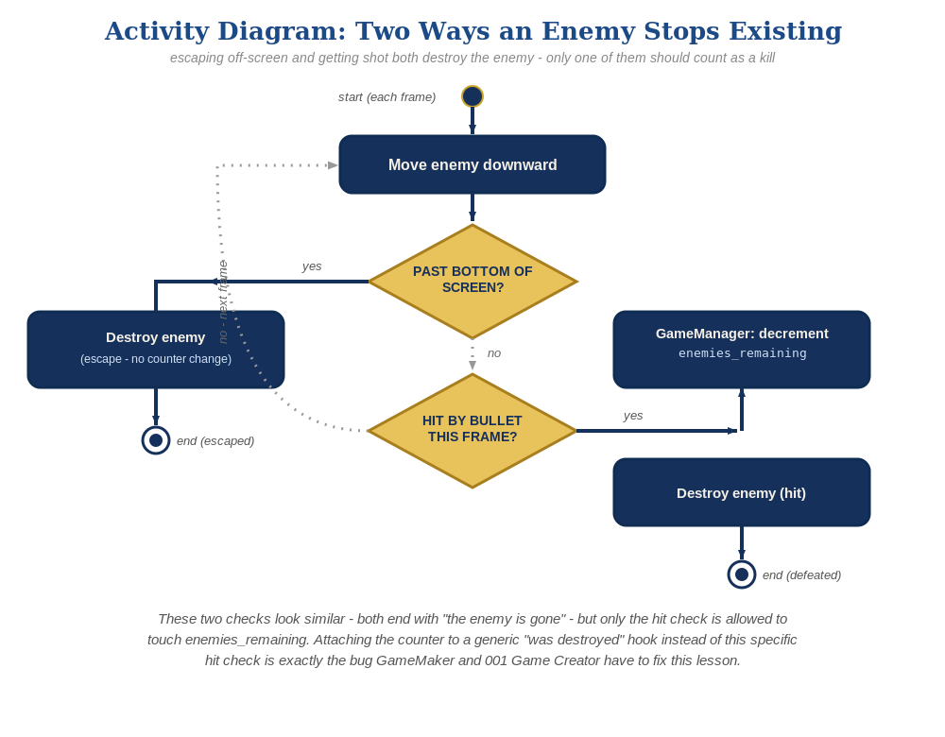
The general escape-vs-hit distinction behind this week's exercise - the same shape in every engine, whatever the exact code or blocks look like.
- The always-true movement event applies Enemy.Y() + 30 * TimeDelta() to every Enemy instance each frame - GDevelop applies per-instance events to every existing instance of that object automatically, no explicit loop needed.
- The escape-cleanup event's condition (Enemy.Y() > 750) and action (Delete Enemy) are new, independent of the Combat group.
- TimeDelta() keeps movement frame-rate independent, consistent with patterns taught since Lesson 2.

Why This Structure
- GDevelop's per-object event model (an event's actions apply to every matching instance automatically) means the movement and escape-cleanup events don't need to reference EnemiesRemaining at all - they operate purely on position.
- The Combat group's collision condition remains the only event in the entire sheet that changes EnemiesRemaining - worth pointing this out explicitly as the reason nothing broke.
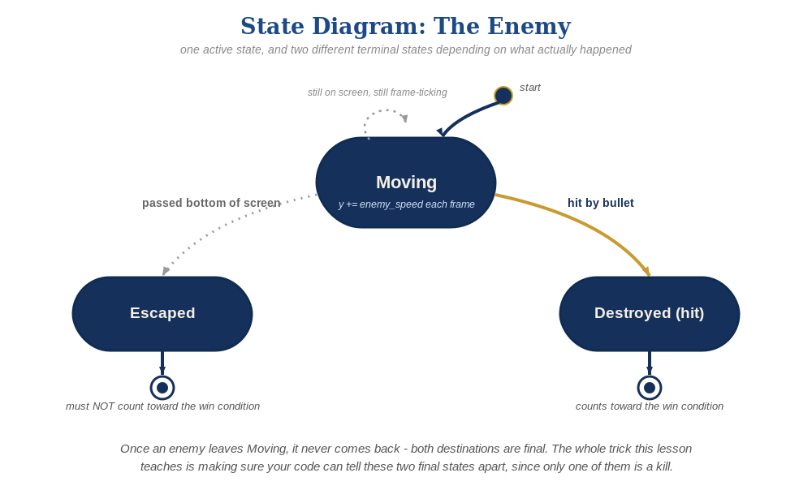
The enemy's two possible endings this week - only one of them should count as a kill.

Level 2 / Level 3 Talking Points
- Ask students to locate every place in their event sheet that changes EnemiesRemaining before and after this lesson - it should still be exactly one place.
- Level 3 structure: grouping movement/escape-cleanup into a labeled 'Enemy Movement' group (separate from 'Combat' and 'Spawn Enemies') previews the kind of organization a much larger event sheet will need by Lesson 11.

Common Student Mistakes
- Adding a condition to the movement event 'so it doesn't run all the time' - it should have no condition; that's what makes it run every frame.
- Using Scene.TimeDelta() instead of TimeDelta() by itself, or omitting it entirely (speed becomes frame-rate dependent).
- Setting the Enemy.Y() > 750 threshold using the wrong axis direction and having enemies vanish immediately.

